Come and join us for an evening of music with the…
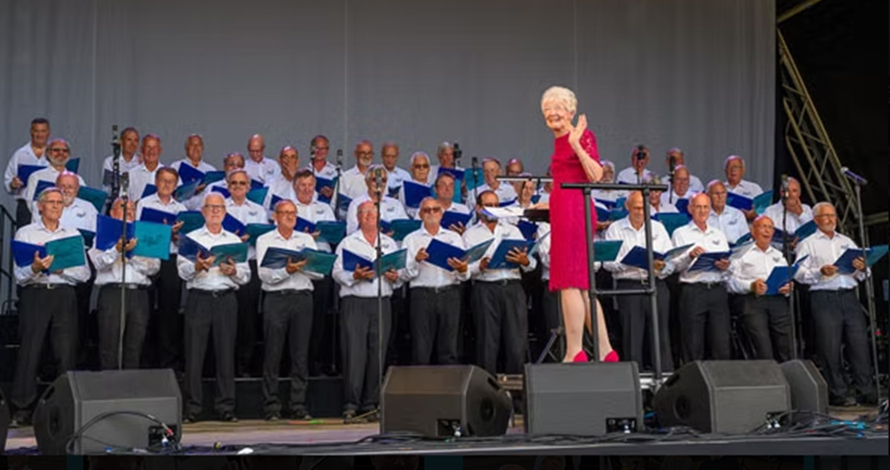

The choir’s repertoire is varied and includes a wide variety of music from classical pieces to songs from the shows, sea shanties, folk songs, Zulu chants, rock’n’roll and much more.
North Cadbury Village Hall
Friday 17th April
Doors open at 7pm. Music starts at 7.30pm
Tickets: Adults £10 U16’s £5 Licensed Bar
Available from North Cadbury Village Store or www.ticketsource.co.uk/north-cadbury-village-hall

