NORTH CADBURY CINEMA
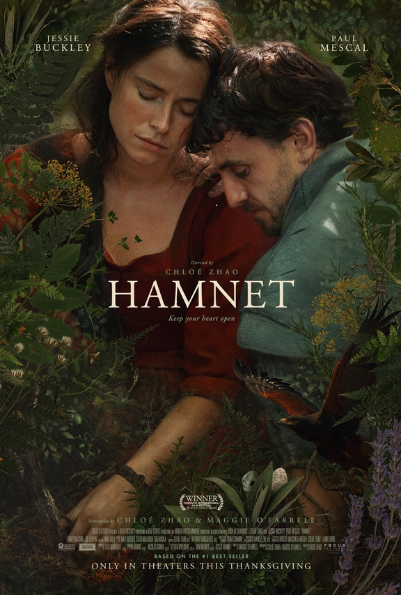
Hamnet is a 2025 historical drama film directed by Chloé Zhao, who co-wrote the screenplay with Maggie O'Farrell, based on the 2020 novel by O'Farrell. The film dramatises the family life of William Shakespeare and his wife Agnes Hathaway as they cope with the death of their 11-year-old son Hamnet. It stars Jessie Buckley and Paul Mescal as Agnes and William, alongside Emily Watson, Joe Alwyn, and Jacobi Jupe in supporting roles.
Thursday 14th May 2026 at North Cadbury Village Hall
Doors open at 7pm for Licensed Bar.
Adults £6 Under 16’s £4 on the door.

