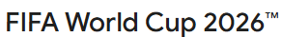

The World Cup is coming to North Cadbury!

Bring along your friends to North Cadbury’s very own Fan Zone. We will be showing some World Cup 2026 matches on our huge screen using our brand new 7000 Lumens projector.
The bar will be open and the atmosphere will be amazing.

Group Stage · Wednesday 17th June – 9pm
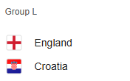

Group Stage · Tuesday 23rd June – 9pm
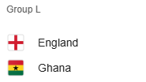

Group Stage · Saturday 27th June – 10pm
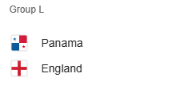
Match times as shown above, the bar will be open earlier.
More matches will be added as the tournament progresses

